4to Medio - Guía 7
Lesson 4: Go after your Dreams
English Dept.
Objetivo: Comprender el extracto de un texto no literario reconociendo un vocabulario básico en inglés.
Nombre |  | Curso |  | Fecha

- Read the following extract, and answer the questions below.
The longing for home (extract)
When I was in my fifties and early sixties even, I deluded myself with the fantasy that I was still somehow middle-aged and has roughly as much time left to live as I had lived already, which seemed endless enough for all practical purposes. But now that I find myself pushing seventy hard, I have finally begun to wise up. It is no longer just in my mind that I know I am rather a good deal closer to the end of my time than I am to its beginning. I know it in my stomach, and there is a lot of sadness in knowing it. But that is by no means all there is. Who would want it to be day forever and never night, after all? Who would choose to be awake forever and never get a chance to sleep? But the tide that carries us farther and farther always from our beginning in time is also the tide that turns and carries us back again. In other words, it is true what they say: the older we grow, the more we find ourselves returning to the days when we were young. More vividly than ever before, I think, we find ourselves remembering the one particular house that was our Childhood home. We remember the books we read there. We remember the people we loved there. The first group of pieces in this collection has to do with home in that sense- the home we knew and will always long for. Be homesick for.

- What is the narrator talking about? Explain in your own words.
__________________________________________________________________________
__________________________________________________________________________
- What does the narrator long for?_______________________________________________
__________________________________________________________________________
- What do you long for in your past?______________________________________________
__________________________________________________________________________
- What is the feeling the text gave to you?
__________________________________________________________________________
__________________________________________________________________________
- Do you think you will feel the same way the writer did as an older person? Why? Why not?
__________________________________________________________________________
__________________________________________________________________________

- Look for at least 10 words you don´t know from the text and look for their meaning in Spanish/ Busca al menos 10 palabras que no conozcas del texto, y busca su significado.
1. 5. 9.
2. 6. 10.
3. 7.
4. 8.

- Underline all the verbs you find in the text/subraya los verbos que encuentres en el texto

- Searchword: Look for the key words of the unit.
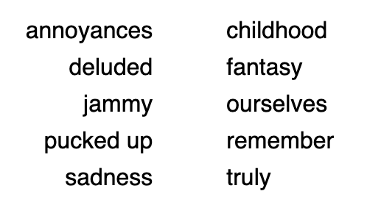
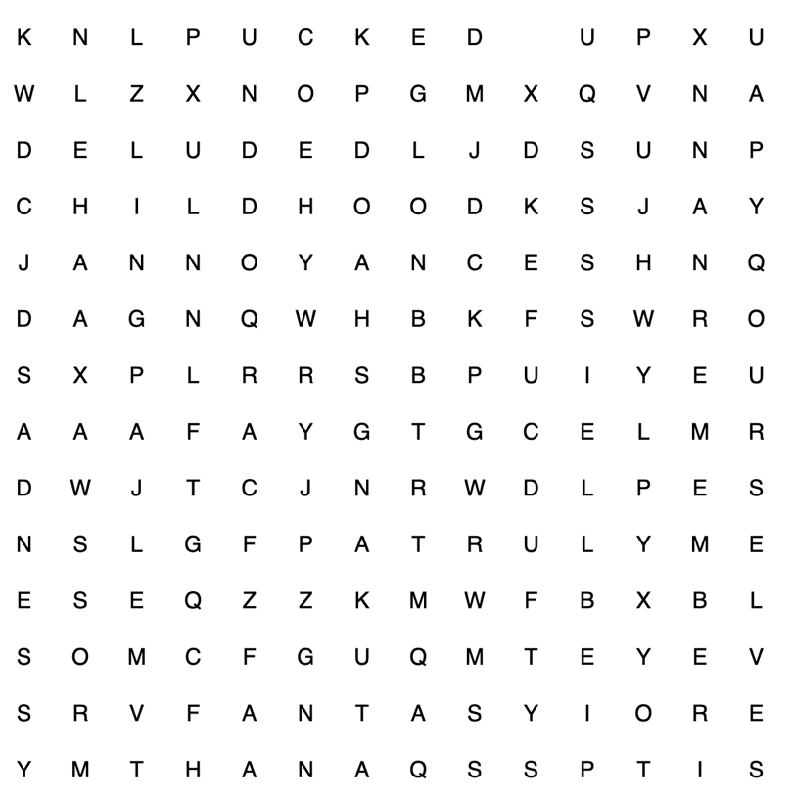


Esta guía NO ES EVALUADA, por lo tanto no debes reportarla a tu profesor. Solo se trabaja en casa.
Si tienes alguna duda o necesitas ayuda para realizarla, comunícate con tu profesor correspondiente.
Miss Hilia Parra hparra@isett.cl
Mister Kevin Caroca kcaroca@isett.cl

