2nd Grade - Guía 7
“TRADITIONS AROUND THE WORLD”

Name: |  | Grade: |  | Date:
Objetivo: | - Reconocer vocabulario relacionado a tradiciones, celebraciones y festividades del mundo.
Departamento de Inglés.
- Celebrations

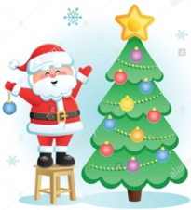
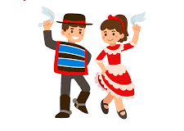


Valentine´s Day
Independance Day
Mother´s Day
Christmas

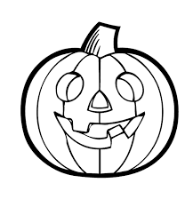
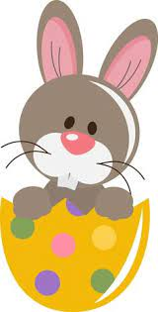
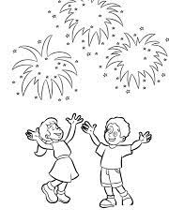
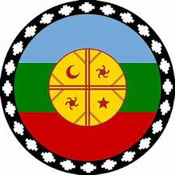

wüñoy Tripantu
Halloween
Easter
New Year´s eve

- Let´s see vocabulary about some celebrations.
English | Spanish | English | Spanish | English | Spanish
Birthday | Cumpleaños | Baptism | Bautismo | Present | Regalo
Christmas Tree | Regalo | Parade | Desfile | Costume | Disfraz
Baloon | Globo | Graduation | Graduación | Food | Comida
Easter | Pascua | Carnival | Carnaval | Tradition | Tradición
Wedding | Matrimonio | Ribbon | Cinta | wreath | Girnalda

- Asnwer the following questions. Remember to use the structure: November 4th, or January 10th etc.

- When is your Birthday? __ _______________________
- When do you celebrate Independence day? __________________________
- When do you Celebrate Mother´s day?_________________________
- When do we celebrate Chirstmas? _________________________

- Do you know any other celebration around the world? Here you have some.

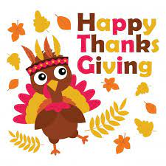
Thanksgiving Day, it is a National holiday in the United States and Canada celebrating the harvest and other blessings of the past year

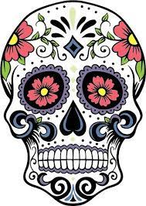
Day of the dead: Mexican holiday that draws on indigenous and European traditions. Assured that the dead would be insulted by mouring or sadness. They celebrate the deceased with food, drink, parties and activities the dead enjoyed in life.

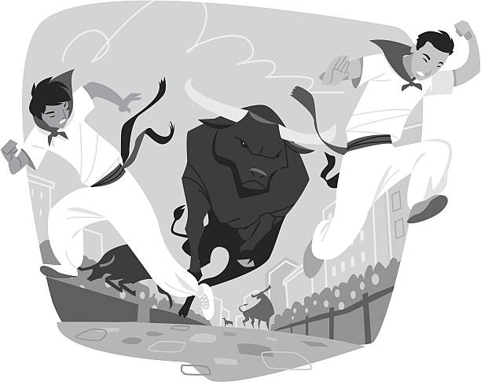
The Official Spanish name is Sanfermin. We refer to it here as San fermin Festival for clarity. The actual, physical running of the bulls on the strees starts on the second day of the San fermin festival.

GUÍA NO EVALUADA, no debes reportar esta guía a tu profesor, solo debes trabajarla en
Casa. Si tienes alguna duda, escríbele a tu profesor correspondiente.

