 | MATERIAL DE ESTUDIO TERCERO MEDIO |  |  |  | N° 4
 | Name: |  | Grade: 3rd
 | ENGLISH DEPARTMENT
Objetivo: Conocer tres tradiciones de Gran Bretaña.
Identificar información específica del texto “British tradition”
Unidad 2: Customs and Traditions all over the World.

Instrucciones:
- Look at these pictures and think what is the topic about.

- British Morris Dancing in summer 3. English Cheese Rolling in spring
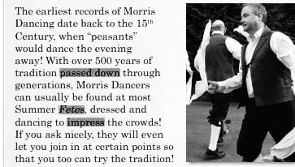
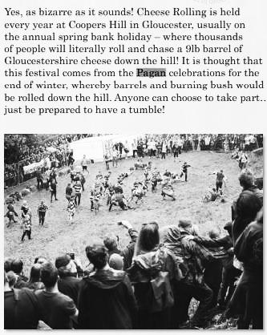
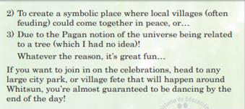
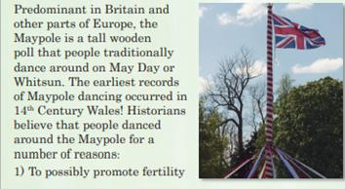

- British Maypole Dancing on May day
Look for the meaning of these words.

1. passed down
2. fetes
3. impress
4. poll
5. pagan
6.bizarre
7. barrel
8. peasant

- Find these numbers in the texts above. What do they refer to?

  - 14th
  - 9lb
c. 500
- Read the statements. Are they true, false, or is the information not mentioned?

  - It is possible to find festivals in the UK during the whole year. _
  - People can even dance with Morris dancers, if they invite them. _
  - Only adults can participate in Morris dancing. _
  - Maypole dancing is exclusively a UK tradition. _
  - The Cheese Rolling event is held on the first day of spring. _
  - Cheese Rolling participants must pay to participate in the competition. _

- Look for the keywords that match each definition besides.

  - _ to give something to someone.
P | A | S | S | D | O | W | N | A | P
L | Z | S | D | W | N | W | H | T | E
T | K | N | S | A | Z | K | I | Y | R
E | W | I | G | E | C | S | O | Q | R
K | I | A | C | Y | R | D | L | H | A
H | P | M | L | M | H | P | Y | W | Z
Z | O | A | H | X | K | B | M | T | I
F | E | T | E | B | U | M | O | I | B

  - to cause someone to admire or respect you.
  - a special celebration, often for a particular purpose, or to honor someone.
  - _ belonging or relating to a modern religion that includes beliefs and activities that not from any of the main religions of the world.
  - very strange and unusual.

VERY IMPORTANT: Una vez realizada tu guía, no debes reportarla a tu profesor (a), te servirá como material de apoyo para las próximas clases.

