2nd Grade / Worksheet 2
“SOCIAL NETWORKS: My Facebook Profile”
Objetivo: Reconocer y aplicar vocabulario de la unidad 1 “Globalization: Social Networks”
Nombre |  | Curso |  | Fecha
Instructions: Complete the Facebook profile according to the contents you saw in classes and your personal information.
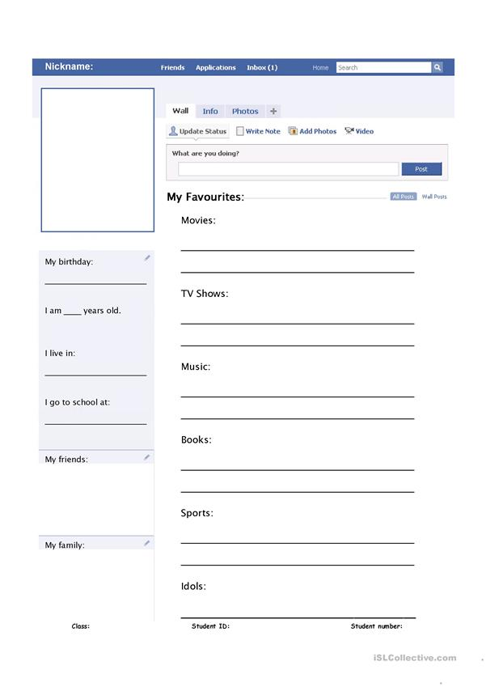
SEND YOUR WORKSHEET TO YOUR TEACHER: hparra@isett.cl / kcaroca@isett.cl

