Guía Número 1 (4to Medio)
Profesores: -Hilia Parra, Ruth Borquez, Kevin Caroca
Objetivo: Reconocer y desarrollar ejercicios de acuerdo al vocabulario aprendido anteriormente.
Nombre |  | Curso |  | Fecha

I.- VOCABULARY: Write the word in SPANISH (4 puntos)
1) Document _____________ 5) Experience ______________
2) Employment ___________ 6) Skills ___________________
3) Professional ___________ 7) Qualifications ____________
4) Work ________________ 8) Strenghts _______________

II.- Write a T for TRUE sentences or F for FALSE sentences (4 puntos)
- _______ A curriculum vitae is a document for applying Jobs.
- _______ The parts of a CV are “Personal Information”, “Skills and Strenghts”, “Education, works and languages”, Interest/hobbies” and “Friends”
- _______ “CV” means Corporation Vitae
- _______ We write all the work experience in our CV.

V.- Answer the questions according to the picture. (4 puntos)
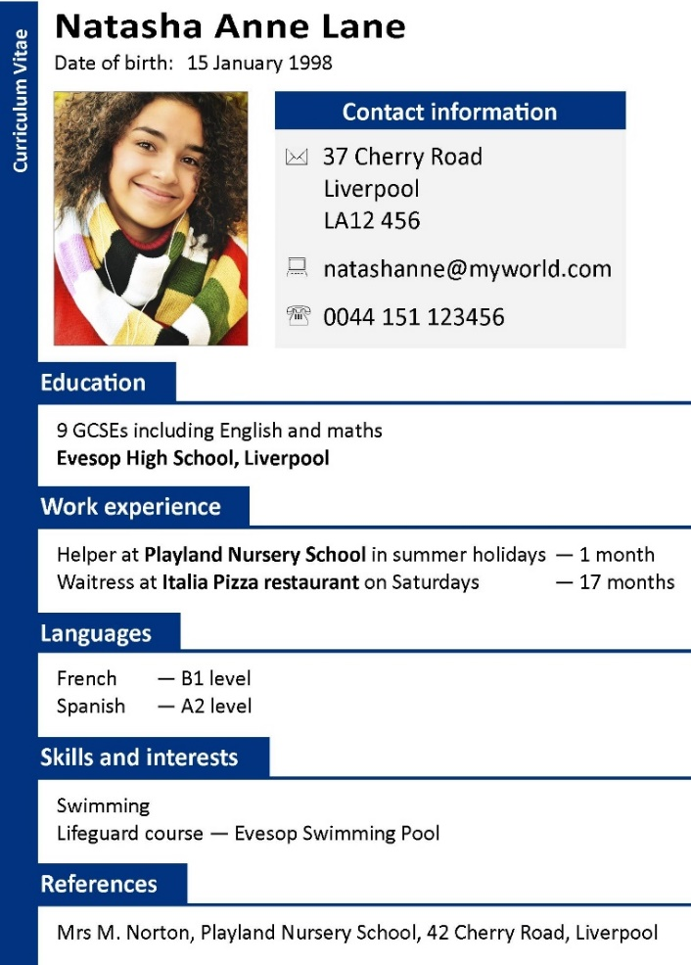
1.- When was Natasha born?
__________________________________________________________________________________
2.- In what places did Natasha work before?
__________________________________________________________________________________
3.- What are the Natasha´s skills and interests?
__________________________________________________________________________________
4.-Where did Natasha study?
__________________________________________________________________________________

